PIONEER JUNIOR COLLEGE, SINGAPORE

JC2 PRELIMINARY EXAMINATIONS
HIGHER 2

CANDIDATE
NAME

CT INDEX
0
9
GROUP NUMBER

CHEMISTRY 9647/02

Paper 2 Structured 21 September 2010

2 hours

Additional Materials: Data Booklet

READ THESE INSTRUCTONS FIRST

Write your Centre number, index number and name on all work you hand in.
Write in dark blue or black pen on both sides of the paper.
You may use a soft pencil for any diagrams, graphs or rough workings.
Do not use staples, paper clips, highlighters, glue or correction fluid.

Answer all questions.

At the end of the examination, fasten all your work securely together.
The number of marks is given in brackets [ ] at the end of each question or part question.

FOR EXAMINER’S USE
1 | / 17 | Paper 1
2 | / 13 | Paper 3
3 | / 13
4 | / 17 | Percentage | / 100
5 | / 12 | Percentage | / 100
Penalty | sf units | Grade
Paper 2 | / 72 | Grade

This document consists of 16 printed pages.

Pioneer Junior College
Answer all the questions in the spaces provided.
For Examiner’s Use

1 | Ammonia is an important material in the production of various products, including nitric acid and fertilisers.
 | (a) |  | Ammonia gas behaves less ideally than nitrogen gas. The following graphs show how the same amount of nitrogen gas and ammonia gas, at the same temperature, behave over a range of pressure.  pV  p  N₂  NH₃
 |  |  | (i) |  |  | On the axes above, sketch a graph to show the behaviour of an ideal gas, of the same amount and with the same temperature as the nitrogen gas and ammonia gas.
 |  |  | (ii) |  |  | Draw a diagram to show the intermolecular forces of attraction between ammonia molecules.
 |  |  | (iii) |  |  | Explain why ammonia does not behave ideally.
 |  |  | (iv) |  |  | A sample of ammonia gas in a vessel has a temperature of 250 ºC and a pressure of 8.0 x 10⁴ Pa. Assuming ideal gas behaviour, calculate the density of the ammonia gas in the vessel.  For Examiner’s Use
 |  |  |  |  |  | [7]
 | (b) |  | An experiment is performed to find the enthalpy change of neutralisation for the reaction between aqueous ammonia and aqueous hydrochloric acid.  The temperature of a 40 cm³ solution of 2.0 mol dm⁻³ aqueous ammonia in a polystyrene cup is measured every 30 seconds for 1.5 minutes.  At the second minute, a 20 cm³ solution of 2.0 mol dm⁻³ aqueous hydrochloric acid is poured into the aqueous ammonia. The temperature of the resulting mixture is then measured every 30 seconds for a further 5 minutes.  The temperatures recorded are plotted on the following axes.  Temperature / ºC  Time / min  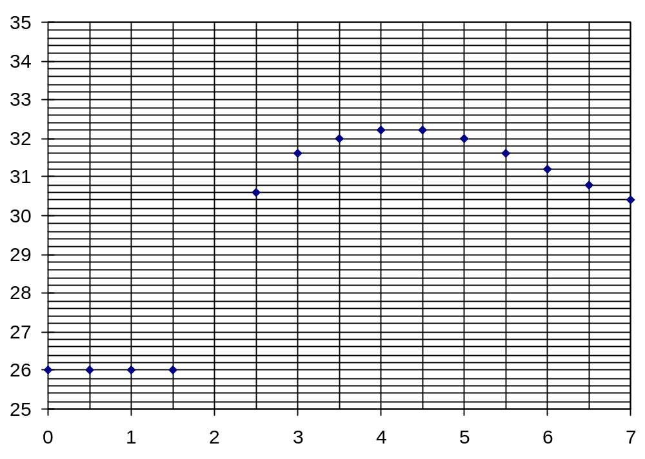  addition of HCl(aq)
 |  |  | (i) |  |  | Give a reason why a 2.0 mol dm⁻³ aqueous solution of ammonia does not contain 2.0 mol dm⁻³ of ammonium ions.  For Examiner’s Use
 |  |  | (ii) |  |  | From the graph of temperatures plotted, find the maximum temperature change of the neutralisation reaction.
 |  |  | (iii) |  |  | The specific heat capacity of the mixture can be assumed to be 4.2 J K⁻¹ cm⁻³. Using your value in (ii), calculate the enthalpy change of neutralisation of the reaction.
 |  |  | (iv) |  |  | When the experiment is repeated with 2.0 mol dm⁻³ ethanoic acid instead of 2.0 mol dm⁻³ hydrochloric acid, the enthalpy change of neutralisation is less exothermic as compared to the answer in (iii). Explain why.
 |  |  |  |  |  | [6]
 | (c) |  | The enthalpy change of formation of ammonia gas is – 46 kJ mol⁻¹. Using this value and other data from the Data Booklet, draw an energy level diagram and calculate the bond energy of N-H bond in ammonia.  For Examiner’s Use
[4]

[Total: 17]

2 | The initial rate of the slow reaction between H₂O₂ and acidified potassium iodide solution can be studied by the “clock” method, using sodium thiosulfate. The equations for the reactions are as follow.  For Examiner’s Use  2I⁻(aq) + H₂O₂(aq) + 2H⁺(aq) ⎯→ 2H₂O(l) + I₂(aq) reaction I  I₂(aq) + 2S₂O₃²⁻(aq) ⎯→ 2I⁻(aq) + S₄O₆²⁻(aq) reaction II  When a small but constant amount of sodium thiosulfate is added to a reaction mixture, the iodine being produced in reaction I will immediately react in reaction II until all the sodium thiosulfate has been used up. At that point, free iodine will be present in the solution, which will cause a sudden appearance of a deep blue colour if starch is present.
 | (a) |  | A series of experiments was carried out using different concentration of hydrogen peroxide, while maintaining a constant volume. The time taken for the deep blue colour to appear are recorded.
  experiment | [H⁺] = [I⁻] = 0.500 mol dm⁻³
  experiment | [H₂O₂] / mol dm⁻³ | time / s | rate
  1 | 0.004 | 74
  2 | 0.006 | 49
  3 | 0.008 | 37
  4 | 0.010 | 30
  5 | 0.012 | 25
 |  |  | (i) |  |  | State the relationship between the time taken for appearance of deep blue colour and the rate. Hence, complete the table above.
 |  |  | (ii) |  |  | Plot a graph of rate against [H₂O₂].
 | 
 |  |  | (iii) |  |  | Deduce, with reason, the order of reaction with respect to hydrogen peroxide from the graph.  For Examiner’s Use
 |  |  | (iv) |  |  | In all the experiments, I⁻ and H⁺ are more concentrated than that of H₂O₂. Explain why this is necessary.
 |  |  |  |  |  | [7]
 | (b) |  | In an attempt to determine the order of reaction with respect to iodide ion, a series of experiments was carried out using different volumes of the five reagents as shown.  (Note: M = mol dm⁻³)
  expt | volume / cm³ |  |  |  |  |  | time / s
  expt | 0.10 M H₂O₂ | 1.00 M KI | 0.10 M HCl | 0.10 M Na₂S₂O₃ | starch | water | time / s
  6 | 5 | 10 | 10 | 2 | 3 | 70 | 100
  7 | 5 | 20 | 10 | 2 | 3 | 60 | 48
  8
 |  |  | (i) |  |  |  | Explain why water is added to the reaction mixture.
 |  |  | (ii) |  |  |  | Deduce the order of reaction with respect to iodide ion. Explain your reasoning clearly.
 |  |  | (iii) |  |  |  | A student wanted to determine the order of reaction with respect to H⁺. Propose a set of experimental conditions in the table above, labelled experiment 8.  [3]
 | (c) |  | The rate of the reaction can be increased by addition of small amount of catalyst. By means of suitable Boltzmann distribution curve, explain how a catalyst speeds up the rate of reaction.  For Examiner’s Use
[3]

[Total: 13]

3 | (a) |  | Suggest explanations for the following, writing equations where appropriate.
 |  |  | (i) |  |  |  | The first ionisation energies of the Period 3 elements generally increase with increasing proton number.
 |  |  | (ii) |  |  |  | Non-metal chlorides like silicon chloride dissolve in water readily to form very acidic solutions of pH 1.
 |  |  | (iii) |  |  |  | Aluminium chloride dissolves in water to form a solution of pH 3.  For Examiner’s Use
 |  |  |  |  |  |  | [7]
 | (b) |  | (i) |  |  |  | Write a balanced equation for the reaction of heat on calcium nitrate.
 |  |  | (ii) |  |  |  | Write equations, including state symbols, when the white solid obtained in (i) is separately subjected to the following:  1. a small amount of water is added.  2. an excess of water is added. Hence, or otherwise, explain what is observed when carbon dioxide is bubbled into this resulting solution.  [4]
 | (c) |  | A 4.19 g sample of a carbonate of a Group II metal, X, lost 1.25 g in mass when heated strongly. Identify metal X.  [2]  [Total: 13]
4 | There are about 600 chemicals that are used as additives in cigarettes. Among these are 2-phenylethanol, phenylalanine, glutamic acid, histidine, threonine and phenylacetaldehyde.  For Examiner’s Use
 | (a) |  | A reaction scheme starting from 2-phenylethanol is as shown.  A  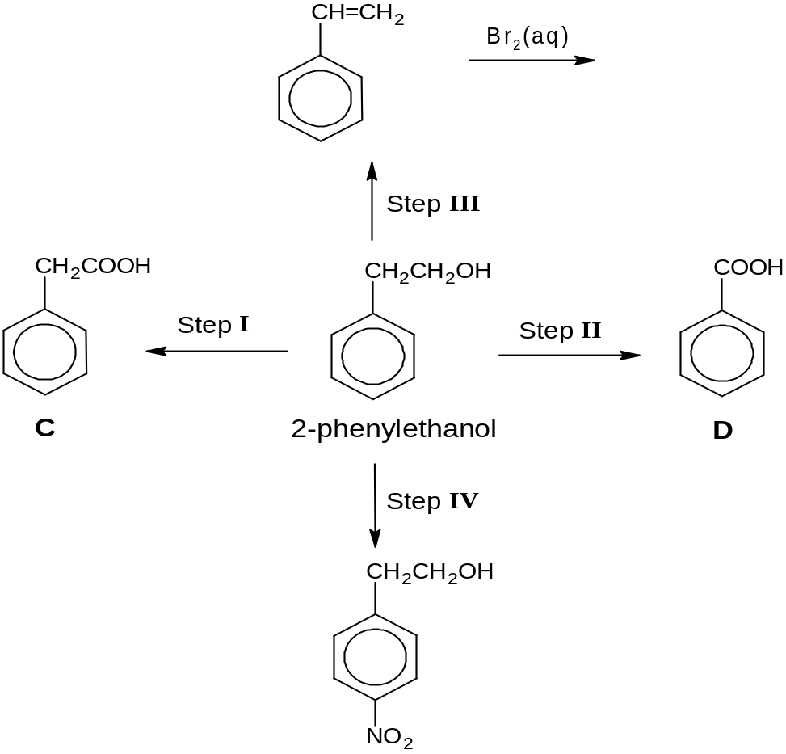
 |  |  | (i) |  |  |  | Draw the structures for compound A in the box above.
 |  |  | (ii) |  |  |  | State the reagents and conditions for Step I, II, III and IV.
step | reagents and conditions
I

II

III

IV

[5]

The pancreas secretes pancreatic juice which contains a digestive enzyme Z. Enzyme Z is a protein molecule that catalyses the breaking down of food in the intestines.
For Examiner’s Use

 | (b) |  | The following amino acids (phenylalanine, glutamic acid and histidine) were obtained when Z was hydrolysed. The three amino acids was added to a buffer solution of pH 6.50 and placed at the centre of a plate (as indicated by the dotted line). The isoelectric points of the three amino acids are as given.  A potential difference was then applied across the plate. Indicate the relative position of the amino acids on the diagram below.
  amino acids | structures | isoelectric points
  phenylalanine  (phe) | 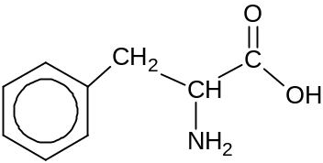 | 5.49
  glutamic acid  (glu) | 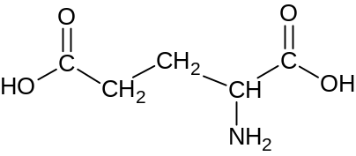 | 3.15
  histidine  (his) | 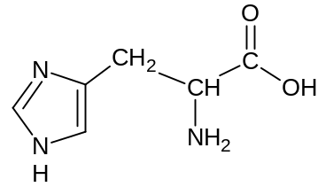 | 7.60

anode (+)
cathode (–)

[2]

 | (c) |  | The function of enzyme Z is affected when the tertiary structure of the protein changes.  For Examiner’s Use
 |  |  | (i) |  |  |  | Define the term tertiary structure of a protein.
 |  |  | (ii) |  |  |  | In a person suffering from a disease that causes diminished secretion of pancreatic enzymes, it is found that phenylalanine in enzyme Z is replaced by the amino acid, threonine, as shown below.  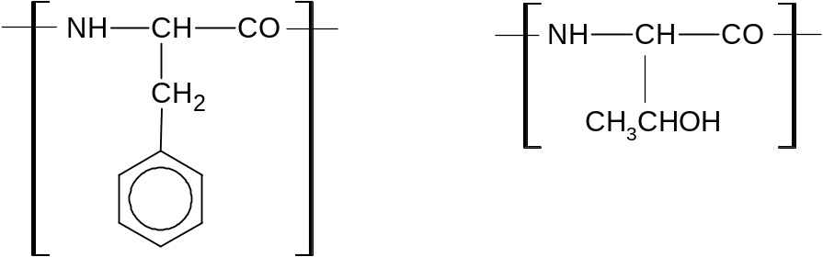  phenylalanine residue threonine residue  Suggest how the difference in structure of the two amino acids might affect the tertiary structure of Enzyme Z.
 |  |  |  |  |  |  | [2]
 | (d) |  | The following method was proposed to synthesise phenylalanine from phenylacetaldehyde.  For Examiner’s Use
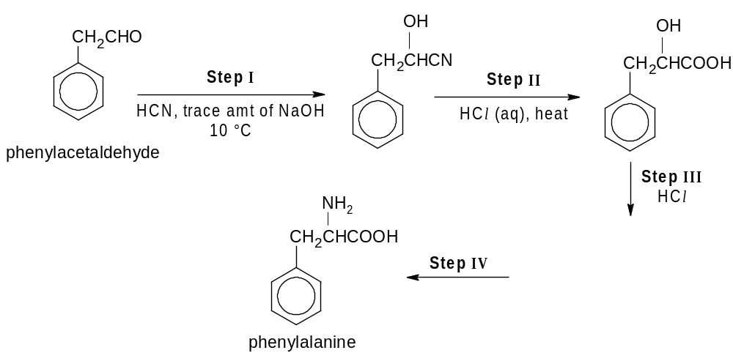
G

 |  |  | (i) |  |  |  | Give the structural formula of compound G in the box above.
 |  |  | (ii) |  |  |  | Suggest reagents and conditions for Step IV.
 |  |  | (iii) |  |  |  | State the type of isomerism shown by phenylalanine produced in the synthesis above.
 |  |  | (iv) |  |  |  | Describe the mechanism in Step I.
 |  |  | (v) |  |  |  | Explain why the product obtained in (iv) does not rotate plane polarised light.  For Examiner’s Use
[8]

[Total: 17]

5 | The labels of 4 bottles have fallen off. Each bottle contains one of the following:  - butan-2-ol  - butanal  - butanone  - an aqueous solution of iron(III) chloride
 | (a) | State the reagents you would use, and observations you could make, to conclusively identify the iron(III) ions. You do not need to test for the other organic compounds.
 |  | [2]
 | (b) | (i) |  |  |  |  |  | Describe the procedures of simple chemical tests by which you could identify each of the organic substances. You are not allowed to identify the substances by elimination. You do not need to identify the aqueous solution of iron(III) ions anymore.  For Examiner’s Use
 |  | (ii) |  |  | For the tests you proposed in (i), state and briefly explain any one issue of reliability or limitations that may be present.  For Examiner’s Use
 |  |  |  |  | [8]
 | (c) | State and explain two safety precautions employed in the course to distinguish the four unknowns given.
[2]

[Total: 12]

